**Task 1**

Write an assembly language that compares the values A and B and prints a message if the value in A is greater than B, less than B.

**Solution:**

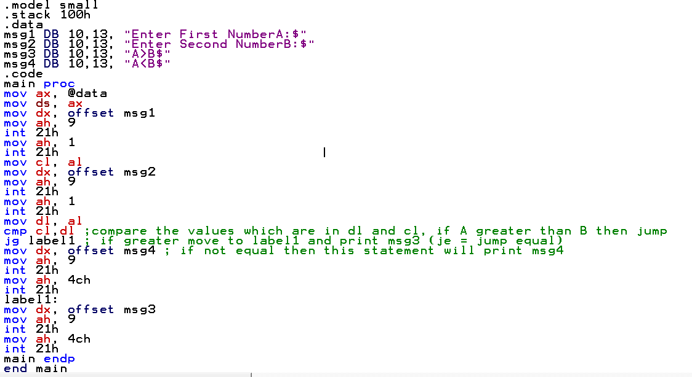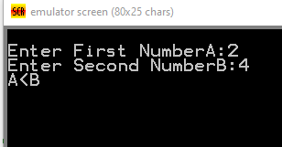

**Task 2**

Write an assembly language program that allow user to input one-digit number and determine the number is positive or negative.

**Solution:**

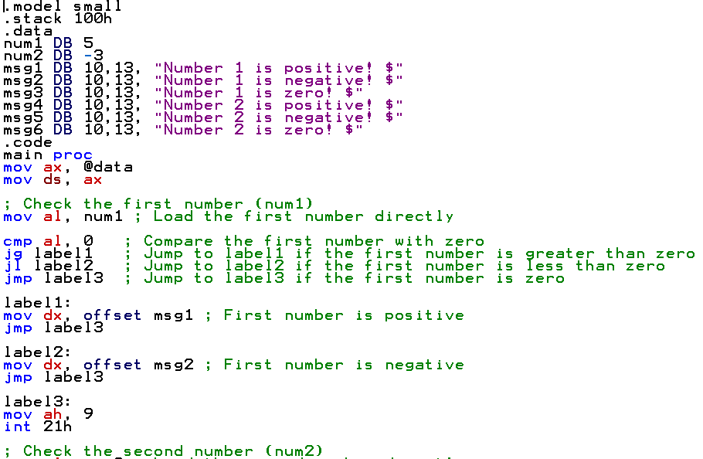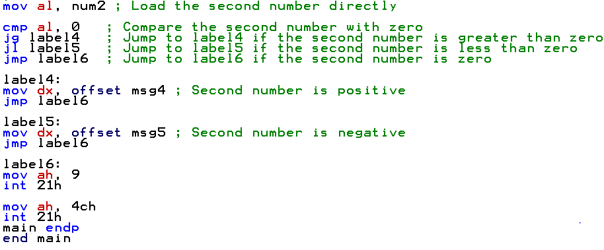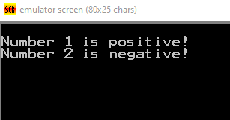

**Task 3**

Write an assembly language program that allow user to input one-digit number and determine if it is even or odd.

**Solution:**

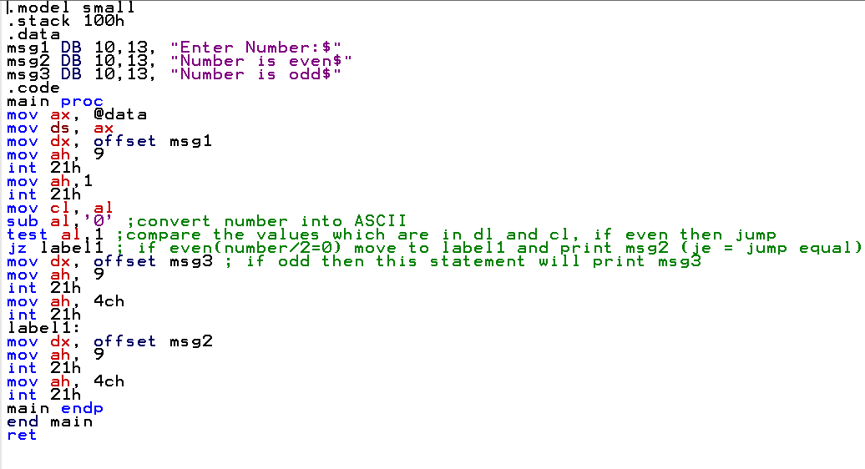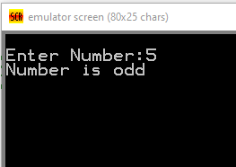

**Task 4**

Create an assembly program which takes your Marks in lab mid as input, if your marks are less than 5 messages should be displayed “Need hard work” else print “Satisfactory”.

**Solution:**

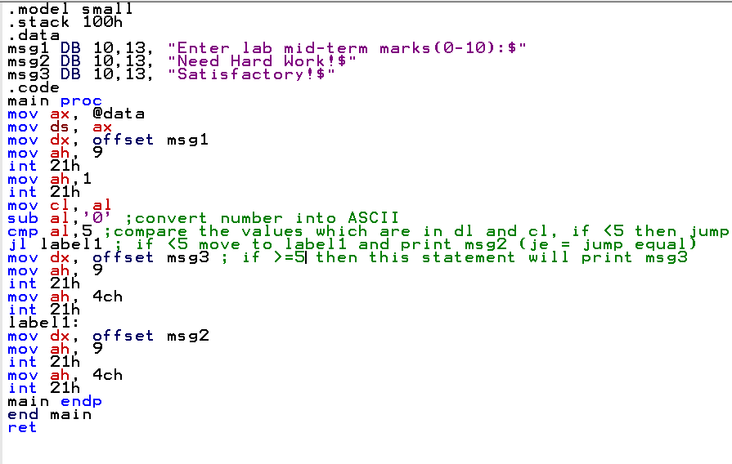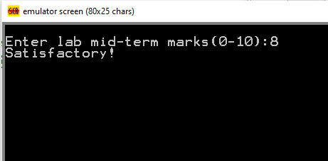

**The End**